1. **Write a program to perform arithmetic operations.**

→

import java.util.Scanner;

class operation

{

public static void main(String args[])

{

Scanner sc = new Scanner(System.in);

int num1, num2, add, sub, mul, div, mod;

System.out.print("Enter 1st number : ");

num1 = sc.nextInt();

System.out.print("Enter 2nd number : ");

num2 = sc.nextInt();

add = num1 + num2;

System.out.println("Addition : "+add);

sub = num1 - num2;

System.out.println("Subtraction : "+sub);

mul = num1 * num2;

System.out.println("Multiplication : "+mul);

div = num1 / num2;

System.out.println("Division : "+div);

mod = num1 % num2;

System.out.println("Modulus : "+mod);

}

}

**o/p :**

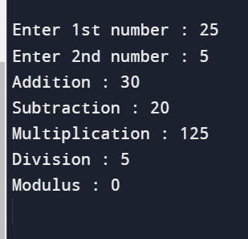

1. **Write a program to convert distance between two cities from kilometers to inches and meters.**

→

import java.util.Scanner;

class convert

{

public static void main(String args[])

{

Scanner sc = new Scanner(System.in);

double km, m, inch;

System.out.print("Enter distance in kilometer : ");

km = sc.nextInt();

m = km * 1000;

inch = km * 39370.1;

System.out.println("Distance in meter : "+m);

System.out.println("Distance in inches : "+inch);

}

}

**o/p :**

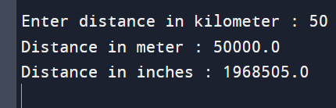

1. **Write a program to input the basic salary of an employee and calculate gross salary according to given conditions :**

**Basic Salary <= 10000 : HRA = 20%, DA = 80%**

**Basic Salary is between 10001 to 20000 : HRA = 25%, DA = 90%**

**Basic Salary >= 20001 : HRA = 30%, DA = 95%.**

→

import java.util.Scanner;

class salary

{

public static void main(String args[])

{

Scanner sc = new Scanner(System.in);

double bs, gs, da, hra, h, d;

System.out.print("Enter basic salary : ");

bs = sc.nextInt();

if(bs<=10000)

{

hra = 0.2;

da = 0.8;

}

else if(bs>10000 && bs<20000)

{

hra = 0.25;

da = 0.9;

}

else

{

hra = 0.3;

da = 0.95;

}

h = hra * bs;

System.out.println("HRA : "+h);

d = da * bs;

System.out.println("DA : "+d);

gs = bs + h + d;

System.out.println("Gross salary : "+gs);

}

}

**o/p :**

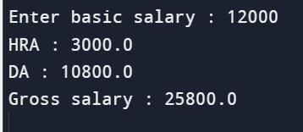

1. **If the ages of three brothers are input through the keyboard, write a program to determine the oldest and the youngest of the three.**

→

import java.util.Scanner;

class brothers

{

public static void main(String args[])

{

Scanner sc = new Scanner(System.in);

String name1, name2, name3;

int b1, b2, b3;

System.out.print("Enter 1st brother's name : ");

name1 = sc.next();

System.out.print("Enter "+name1+"'s age : ");

b1 = sc.nextInt();

System.out.print("Enter 2nd brother's name : ");

name2 = sc.next();

System.out.print("Enter "+name2+"'s age : ");

b2 = sc.nextInt();

System.out.print("Enter 3rd brother's name : ");

name3 = sc.next();

System.out.print("Enter "+name3+"'s age : ");

b3 = sc.nextInt();

if(b1>b2 && b1>b3)

{

System.out.println(name1+" is the oldest");

if(b2>b3)

{

System.out.println(name3+" is the youngest");

}

else

{

System.out.println(name2+" is the youngest");

}

}

else if(b2>b1 && b2>b3)

{

System.out.println(name2+" is the oldest");

if(b1>b3)

{

System.out.println(name3+" is the youngest");

}

else

{

System.out.println(name1+" is the youngest");

}

}

else

{

System.out.println(name3+" is the oldest");

if(b1>b2)

{

System.out.println(name2+" is the youngest");

}

else

{

System.out.println(name1+" is the youngest");

}

}

}

}

**o/p :**

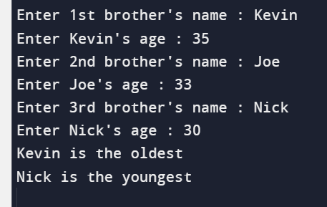

1. **Write a menu driven program with following cases :**

**Case 1 : Check whether the number entered by the user is prime or not.**

**Case 2 : Print the factorial of the number entered by the user.**

**Case 3 : Generate fibonacci series upto the number of elements entered by the user.**

→

import java.util.Scanner ;

public class menu

{

public static void main (String [] args)

{

Scanner sc = new Scanner(System.in);

int num, choice, i, count, fact, a, b, c;

while(true)

{

System.out.println("\nMENU :\n 1 - To check if your number is prime or not,\t 2 - To print the factorial of your number,\t 3 - To print Fibonacci series,\t 4 - EXIT");

System.out.print("Enter your choice : ");

choice = sc.nextInt();

switch (choice)

{

case 1 :

{

System.out.print("Enter any number : ");

num = sc.nextInt();

count = 0;

for(i=1; i<=num; i++)

{

if(num%i == 0)

{

count++;

}

}

if(count == 2)

{

System.out.println(num+" is a prime number.");

}

else

{

System.out.println(num+" is not a prime number.");

}

break;

}

case 2 :

{

System.out.print("Enter any number : ");

num = sc.nextInt();

i = 1;

fact = 1;

while (i<=num)

{

fact = fact * i;

i++;

}

System.out.println(num +"! = " +fact);

break;

}

case 3 :

{

System.out.print("Enter limit : ");

num = sc.nextInt();

a = 0;

b = 1;

c = 0;

i = 0;

System.out.print("Fibonacci Series : ");

for(i=0; i<num; i++)

{

if(i<=1)

{

c = i;

}

else

{

c = a + b;

a = b;

b = c;

}

System.out.print(" "+c);

}

break;

}

case 4 :

{

System.exit(0);

break;

}

default :

{

System.out.println("Enter correct choice : ");

}

}

}

}

}

**o/p :**

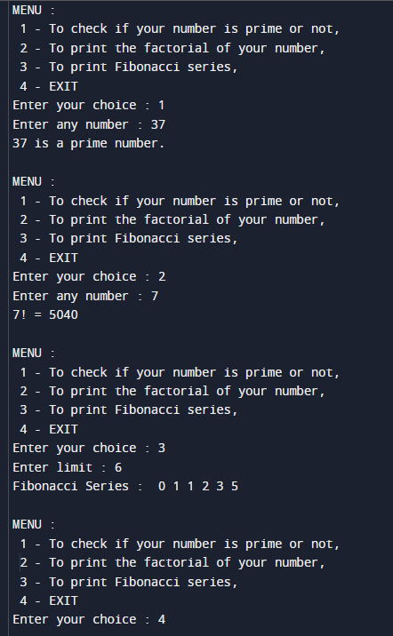

1. **Write a program to print the following number pattern :**

**i.**

**1**

**1 2**

**1 2 3**

**1 2 3 4**

**1 2 3 4 5**

→

import java.io.*;

public class pattern

{

public static void main(String args[])

{

int i, j;

for(i=1; i<7; i++)

{

for(j=1; j<i; j++)

{

System.out.print(j+" ");

}

System.out.print("\n");

}

}

}

**o/p :**

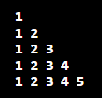

**ii.**

**1 2 3 4 5**

**1 2 3 4**

**1 2 3**

**1 2**

**1**

→

import java.util.Scanner;

public class pattern

{

public static void main(String args[])

{

Scanner sc = new Scanner(System.in);

int i, j;

for(i=5; i>0; i--)

{

for(j=1; j<=i; j++)

{

System.out.print(j+" ");

}

System.out.print("\n");

}

}

}

**o/p :**

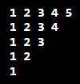

1. **Write a program to print the following patterns :**

**i.**

**\* * * * \***

**\* * * \***

**\* * \***

**\* \***

**\***

→

import java.util.Scanner;

public class pattern

{

public static void main(String args[])

{

Scanner sc = new Scanner(System.in);

int i, j;

for(i=5; i>0; i--)

{

for(j=0; j<i; j++)

{

System.out.print("*");

}

System.out.print("\n");

}

}

}

**o/p :**

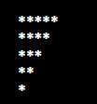

**ii.**

**\***

**\* \***

**\* * \***

**\* * * \***

**\* * * * \***

→

import java.io.*;

public class pattern

{

public static void main(String args[])

{

int i, j;

for(i=0; i<=5; i++)

{

for(j=0; j<i; j++)

{

System.out.print("*");

}

System.out.print("\n");

}

}

}

**o/p :**

